CSA 0618 DAA
TOPIC 1:
EX1:
arr = [10, 25, 30, 45, 50]
key = 30

found = False

for i in range(len(arr)):
if arr[i] == key:
print("Key found at index", i)
found = True
break

if found == False:
print("Key not found")
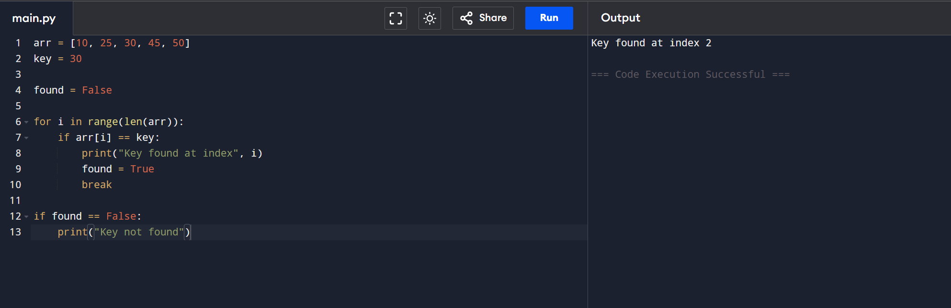
EX2:
def binary_search(arr, low, high, key):
if low <= high:
mid = (low + high) // 2

if arr[mid] == key:
return mid
elif key < arr[mid]:
return binary_search(arr, low, mid - 1, key)
else:
return binary_search(arr, mid + 1, high, key)

return -1

arr = [5, 10, 15, 20, 25]
key = 20

result = binary_search(arr, 0, len(arr)-1, key)

if result != -1:
print("Key found at index", result)
else:
print("Key not found")
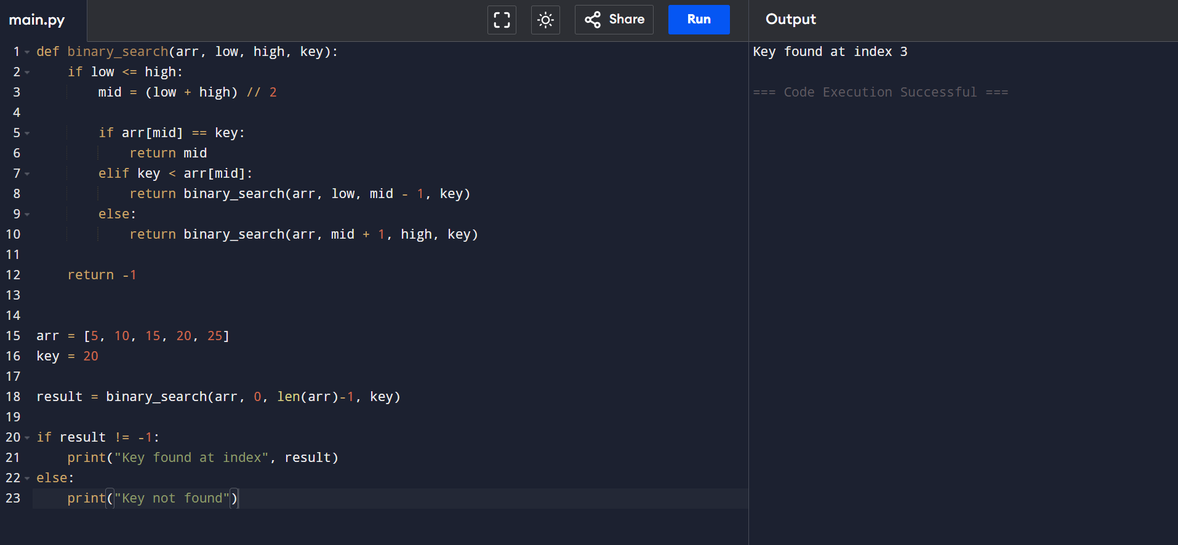
EX 3:
n = 5

# Iterative
fact = 1

for i in range(1, n + 1):
fact = fact * i

print("Iterative Factorial =", fact)

# Recursive
def factorial(num):
if num == 0 or num == 1:
return 1
else:
return num * factorial(num - 1)

print("Recursive Factorial =", factorial(n))
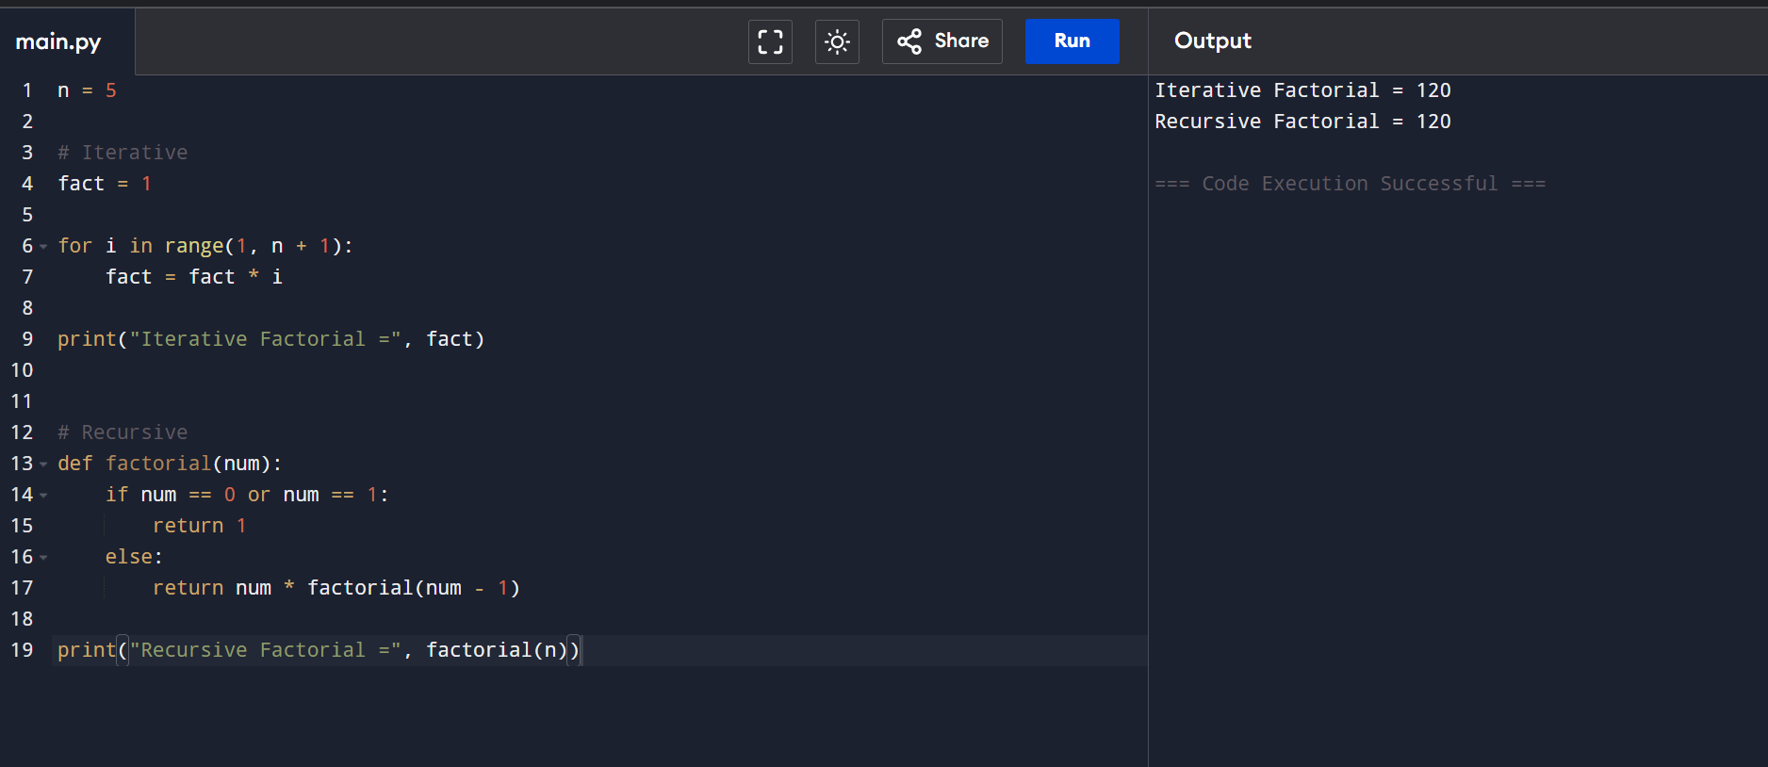
EX 4:
n = 6

print("Iterative Fibonacci:")

a = 0
b = 1

for i in range(n):
print(a, end=" ")
c = a + b
a = b
b = c

print()

print("Recursive Fibonacci:")

def fibonacci(num):
if num <= 1:
return num
return fibonacci(num - 1) + fibonacci(num - 2)

for i in range(n):
print(fibonacci(i), end=" ")
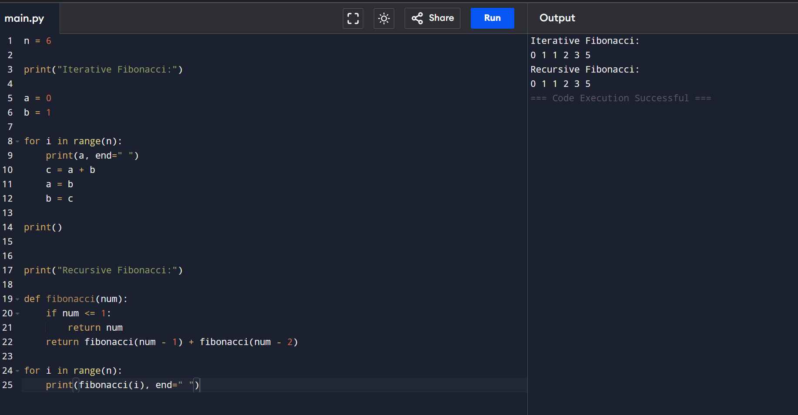
EX 5:
A = [[1, 2],
[3, 4]]

B = [[5, 6],
[7, 8]]

result = [[0, 0],
[0, 0]]

for i in range(2):
for j in range(2):
for k in range(2):
result[i][j] = result[i][j] + A[i][k] * B[k][j]

print("Result Matrix:")

for row in result:
print(row)
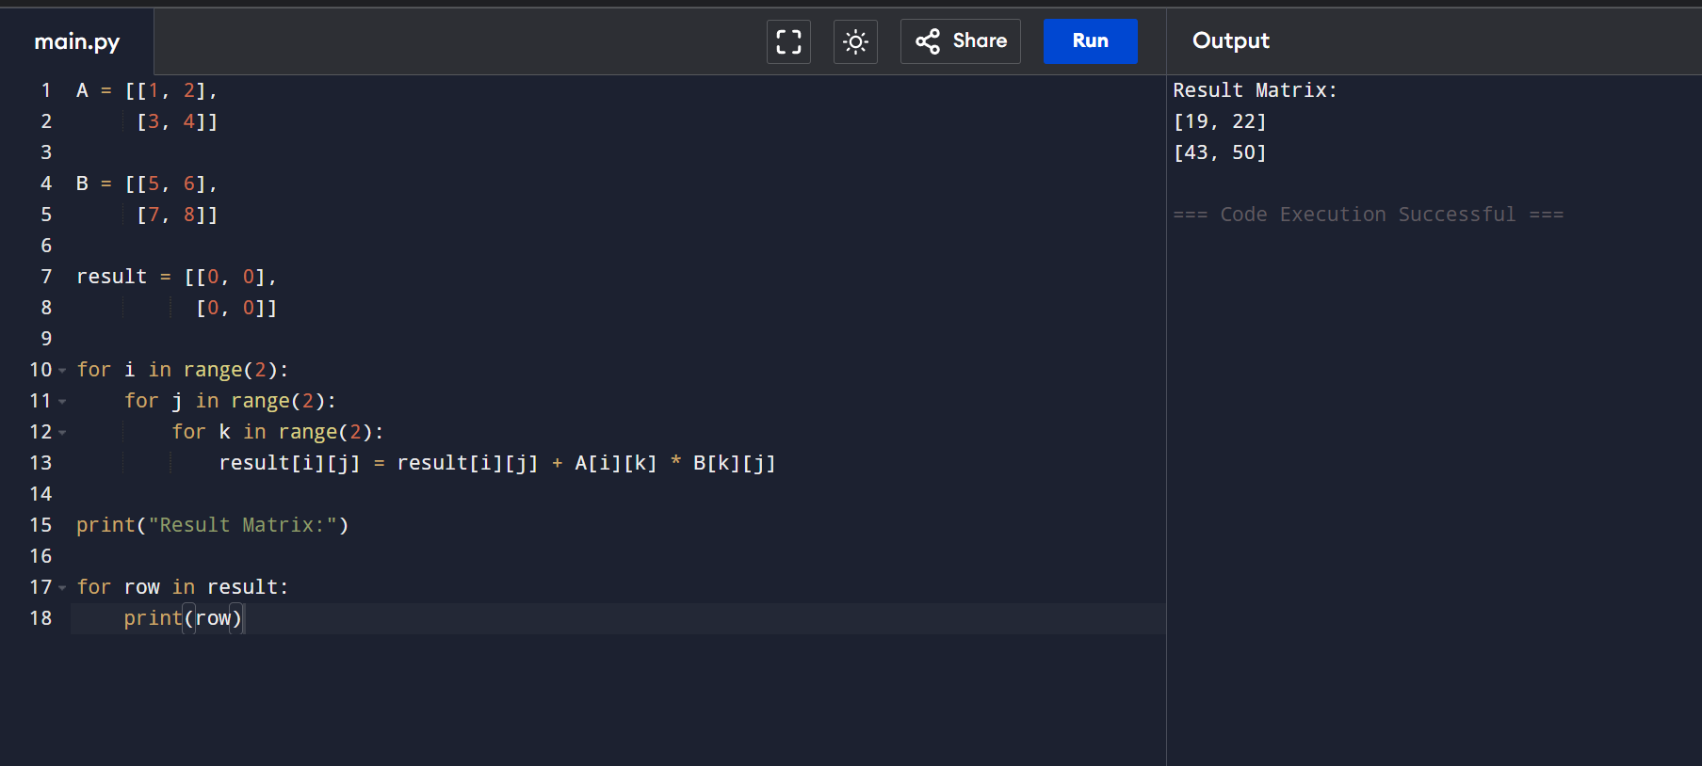
EX 6:
def merge_sort(arr):
if len(arr) > 1:

mid = len(arr) // 2
left = arr[:mid]
right = arr[mid:]

merge_sort(left)
merge_sort(right)

i = j = k = 0

while i < len(left) and j < len(right):
if left[i] < right[j]:
arr[k] = left[i]
i = i + 1
else:
arr[k] = right[j]
j = j + 1
k = k + 1

while i < len(left):
arr[k] = left[i]
i = i + 1
k = k + 1

while j < len(right):
arr[k] = right[j]
j = j + 1
k = k + 1

arr = [38, 27, 43, 3, 9, 82, 10]

merge_sort(arr)

print("Sorted Array:", arr)
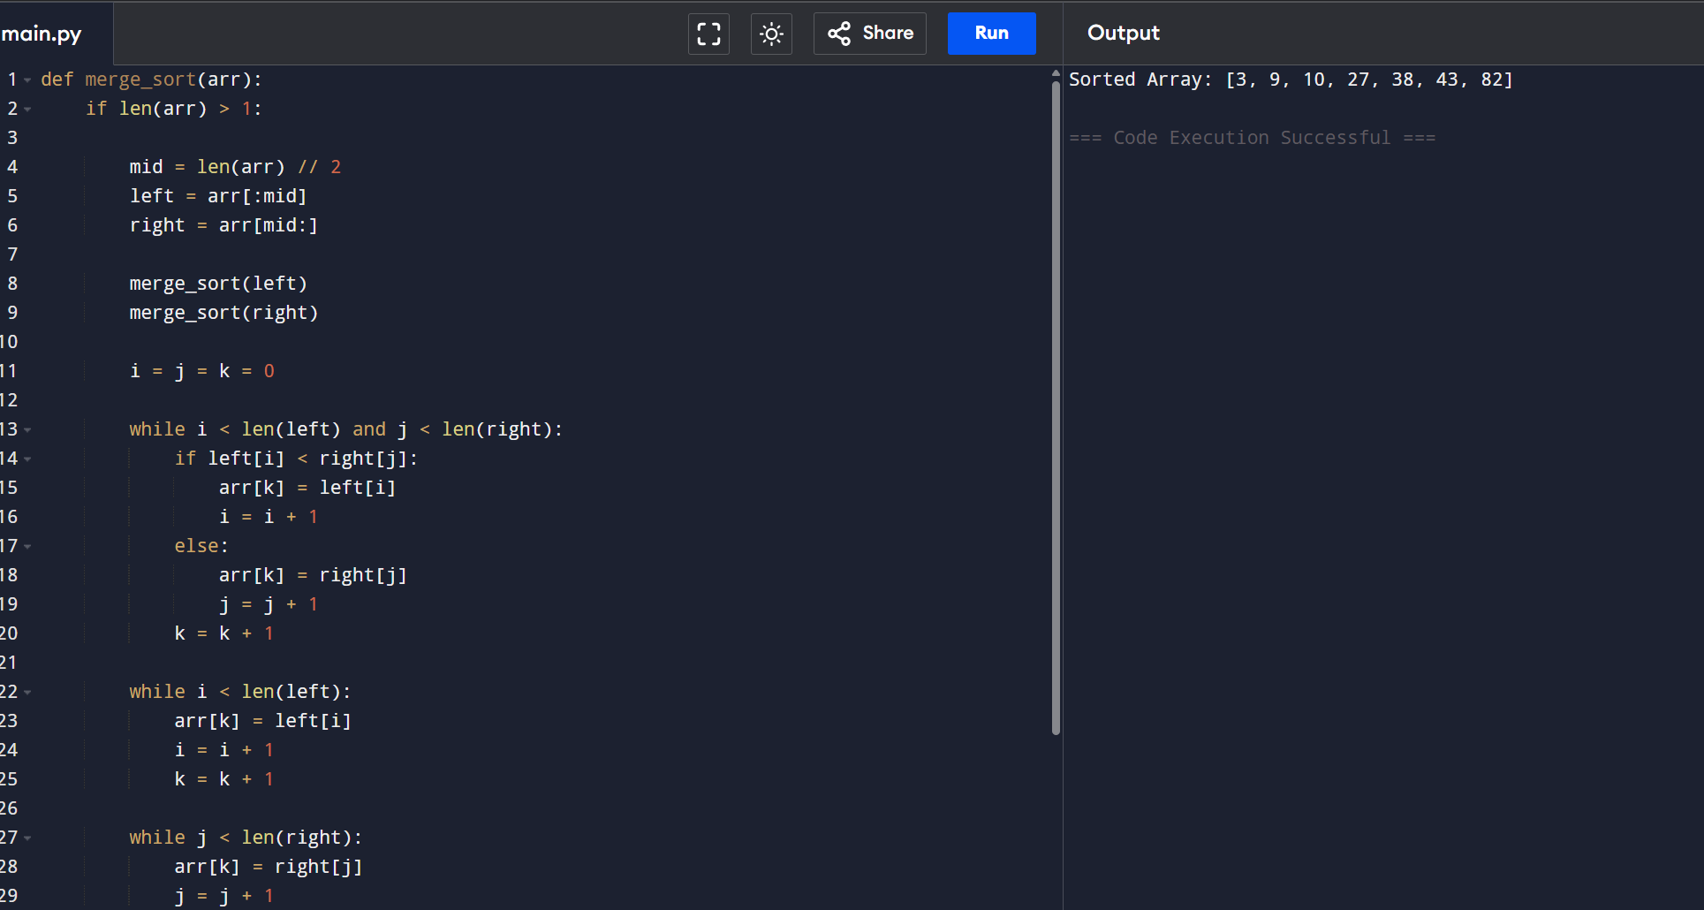
EX :7
def quick_sort(arr):

if len(arr) <= 1:
return arr

pivot = arr[0]

left = []
right = []

for i in arr[1:]:
if i <= pivot:
left.append(i)
else:
right.append(i)

return quick_sort(left) + [pivot] + quick_sort(right)

arr = [10, 7, 8, 9, 1, 5]

sorted_array = quick_sort(arr)

print("Sorted Array:", sorted_array)
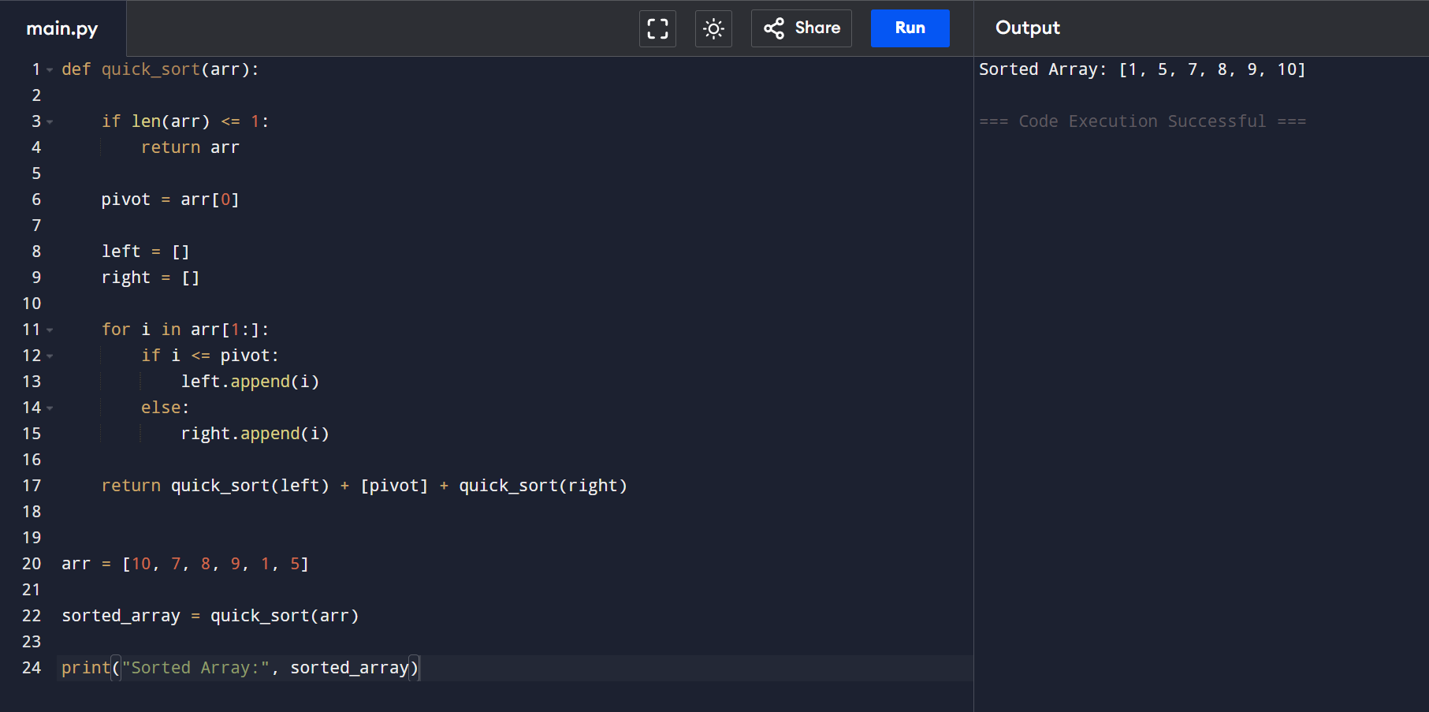
EX :8
def hanoi(n, source, helper, destination):

if n == 1:
print("Move disk 1 from", source, "to", destination)
return

hanoi(n - 1, source, destination, helper)

print("Move disk", n, "from", source, "to", destination)

hanoi(n - 1, helper, source, destination)

n = 3

hanoi(n, 'A', 'B', 'C')
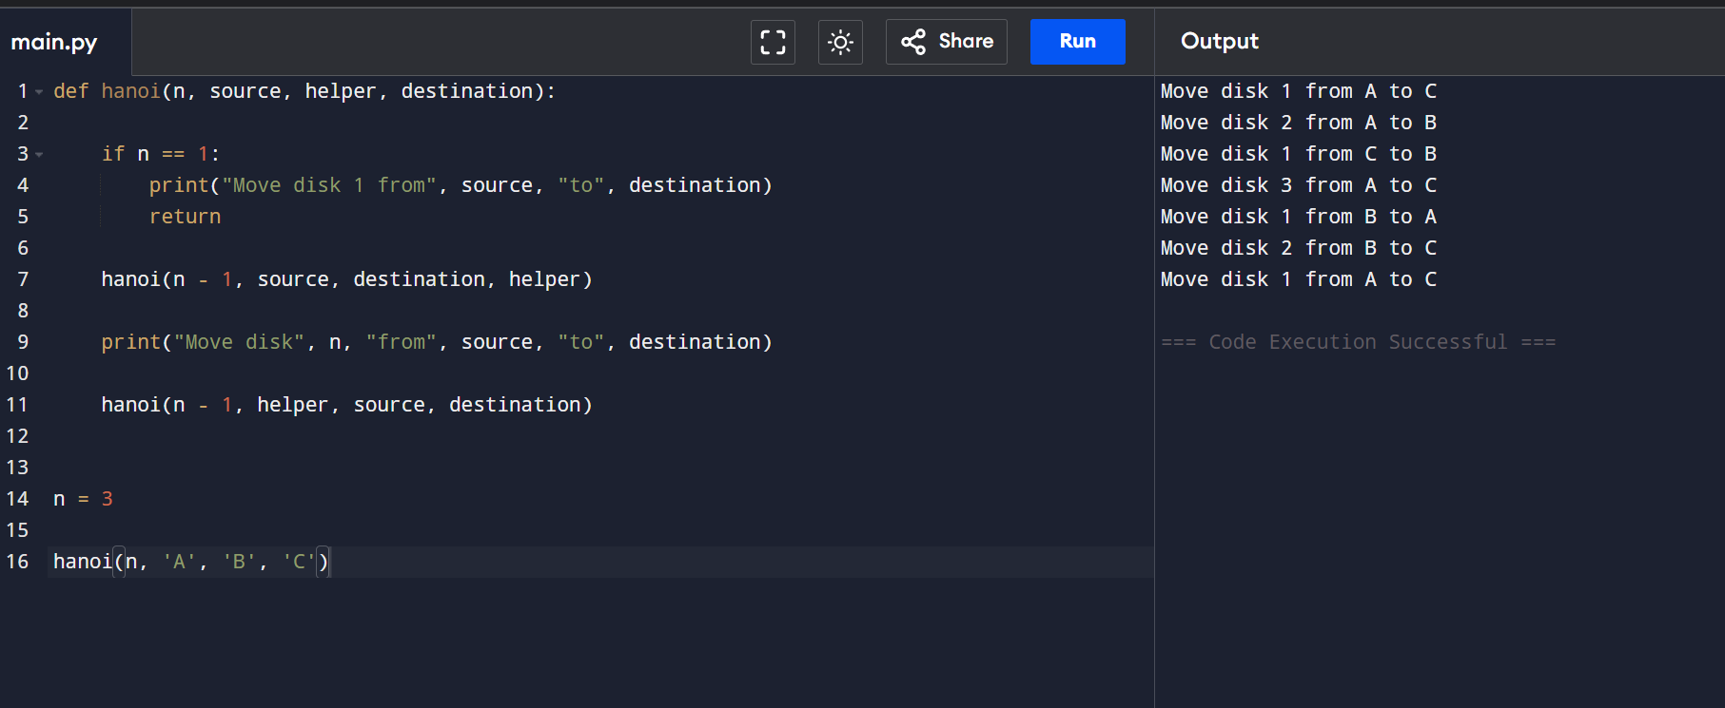
EX :9
def gcd(a, b):

if b == 0:
return a

return gcd(b, a % b)

a = 48
b = 18

print("GCD =", gcd(a, b))
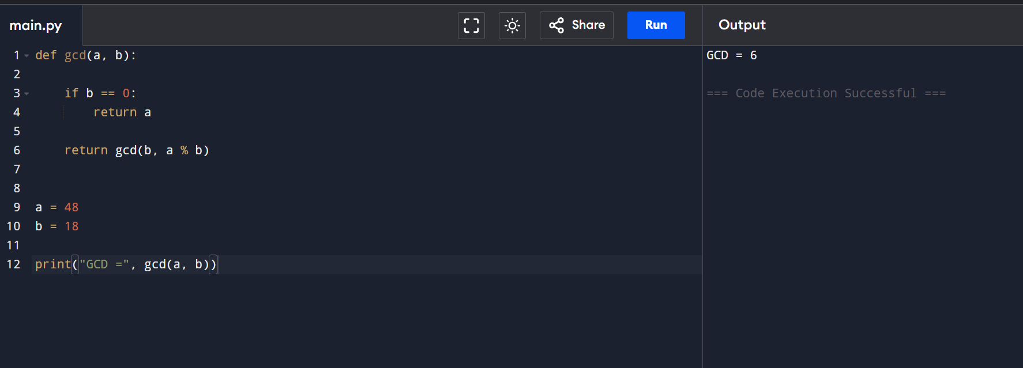
EX 10:
arr = [12, 11, 13, 5, 6]

for i in range(1, len(arr)):

key = arr[i]

j = i - 1

while j >= 0 and arr[j] > key:
arr[j + 1] = arr[j]
j = j - 1

arr[j + 1] = key

print("Sorted Array:", arr)
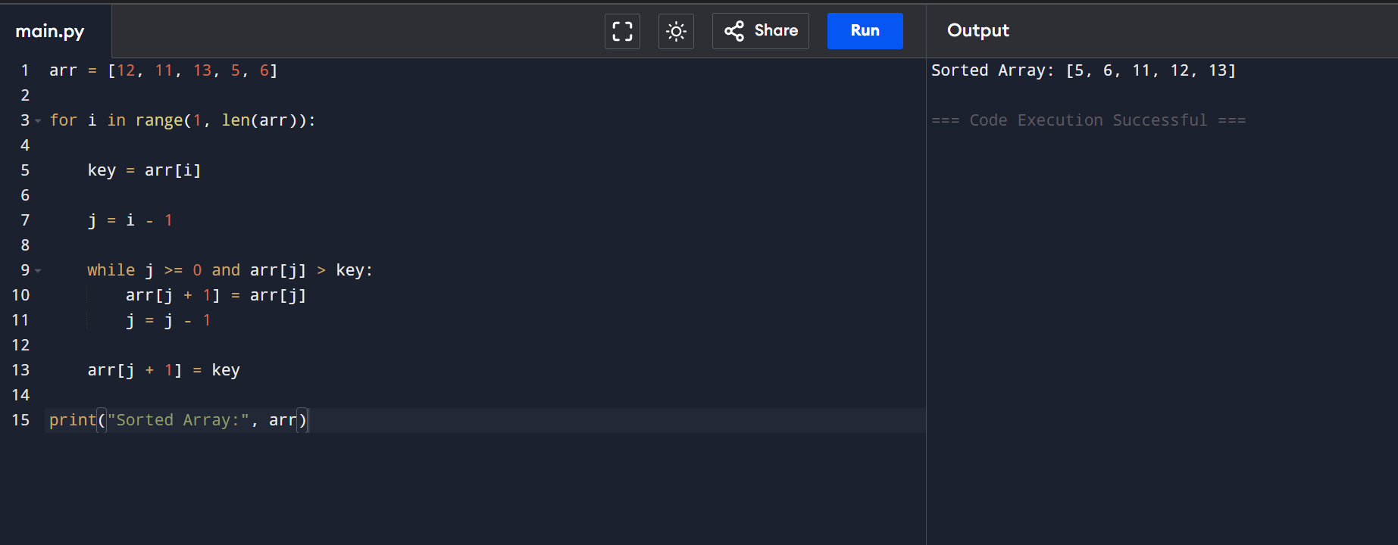
EX 11:
def heapify(arr, n, i):

largest = i
left = 2 * i + 1
right = 2 * i + 2

if left < n and arr[left] > arr[largest]:
largest = left

if right < n and arr[right] > arr[largest]:
largest = right

if largest != i:
arr[i], arr[largest] = arr[largest], arr[i]
heapify(arr, n, largest)

def heap_sort(arr):

n = len(arr)

for i in range(n // 2 - 1, -1, -1):
heapify(arr, n, i)

for i in range(n - 1, 0, -1):
arr[i], arr[0] = arr[0], arr[i]
heapify(arr, i, 0)

arr = [4, 10, 3, 5, 1]

heap_sort(arr)

print("Sorted Array:", arr)
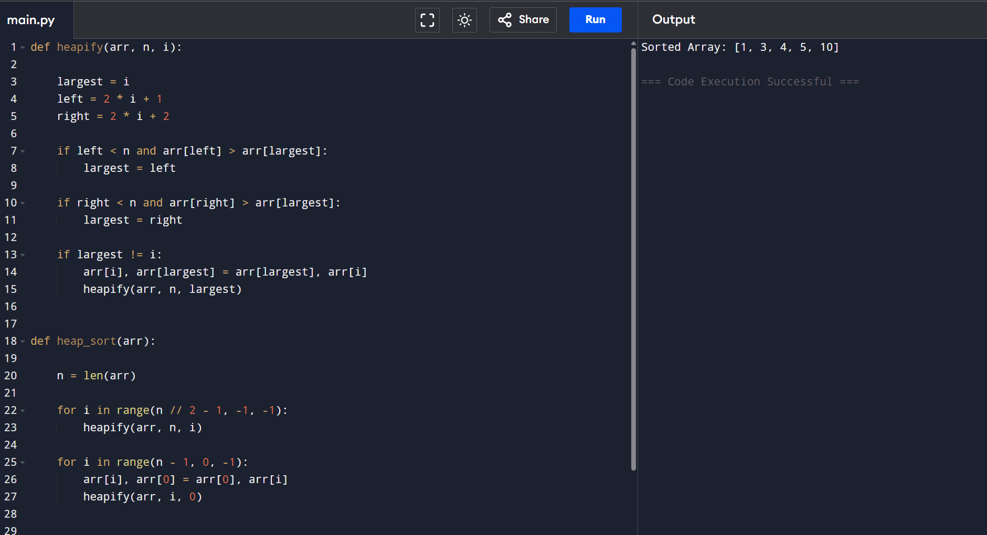
EX 12:
def count_inversions(arr):

count = 0

for i in range(len(arr)):
for j in range(i + 1, len(arr)):
if arr[i] > arr[j]:
count = count + 1

return count

arr = [2, 4, 1, 3, 5]

print("Number of Inversions =", count_inversions(arr))
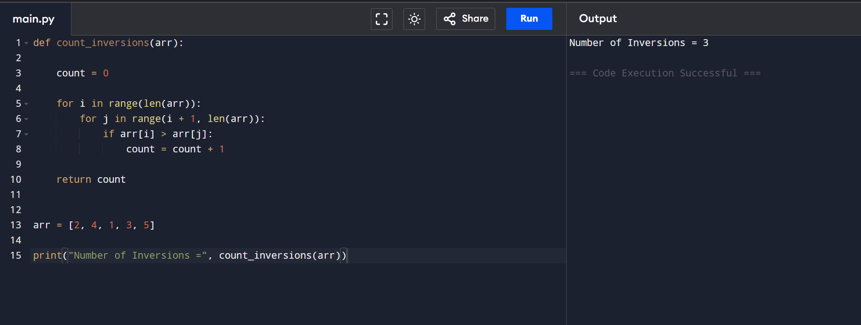
EX 13:
arr = [-2, -3, 4, -1, -2, 1, 5, -3]

max_sum = arr[0]
current_sum = arr[0]

for i in range(1, len(arr)):
current_sum = max(arr[i], current_sum + arr[i])
max_sum = max(max_sum, current_sum)

print("Maximum Subarray Sum =", max_sum)
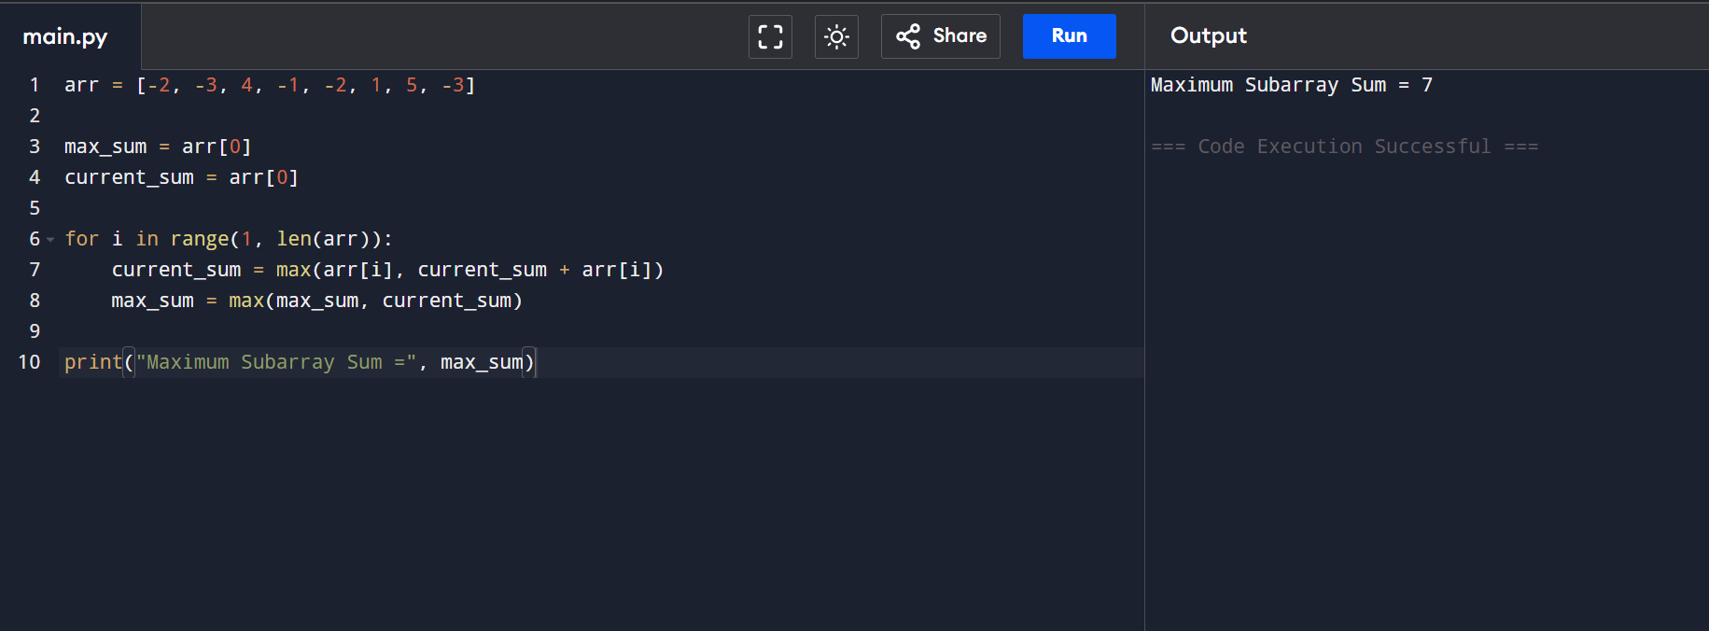
EX 14:
x = 2
n = 10

# Iterative Method
result = 1

for i in range(n):
result = result * x

print("Iterative Power =", result)

# Recursive Fast Power
def power(x, n):

if n == 0:
return 1

if n % 2 == 0:
half = power(x, n // 2)
return half * half

return x * power(x, n - 1)

print("Recursive Fast Power =", power(x, n))
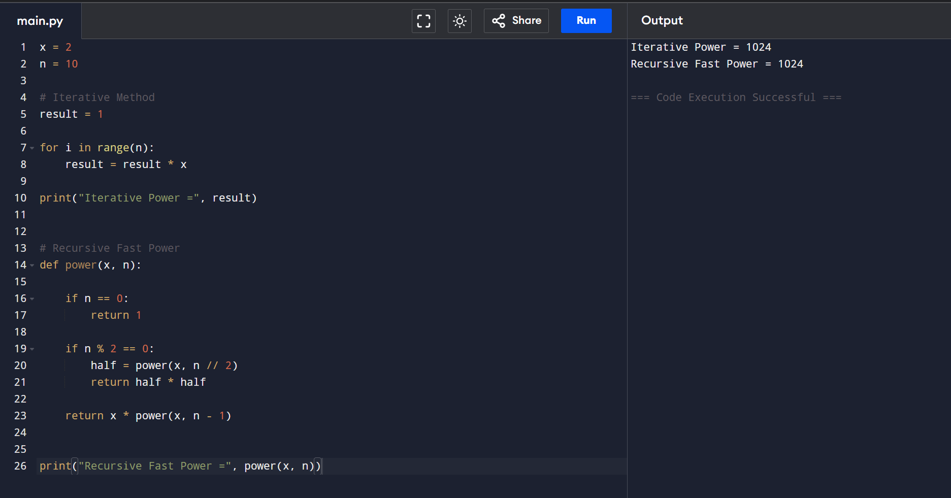
EX 15:
import math

points = [(1, 2), (4, 5), (7, 8), (3, 1)]

min_distance = 100000
pair = ()

for i in range(len(points)):
for j in range(i + 1, len(points)):

x1, y1 = points[i]
x2, y2 = points[j]

distance = math.sqrt((x2 - x1)**2 + (y2 - y1)**2)

if distance < min_distance:
min_distance = distance
pair = (points[i], points[j])

print("Closest Pair =", pair)
print("Distance =", min_distance)
